Clearing Error 2 Gac 2700

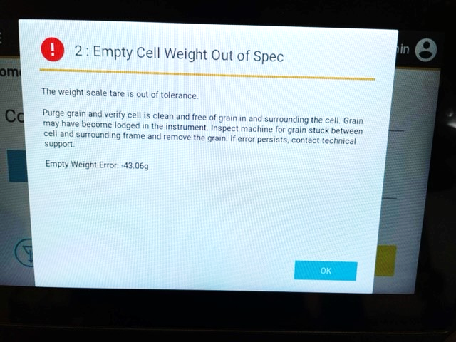

- Make sure that the shipping brackets are moved into the operational position and are not still locked into place. Also make sure that there is no grain stuck inside.
Once that is verified then you must hit the “OK” button to clear the error.

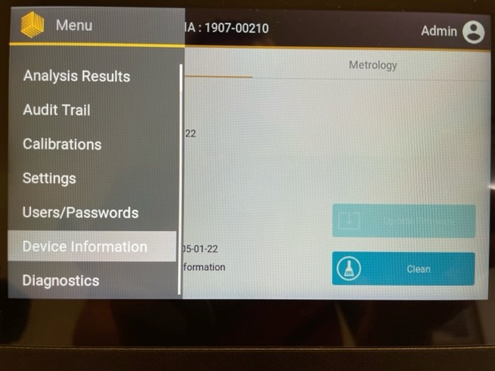

- Navigate to the diagnostics menu. This is located as the bottom option in the menu.

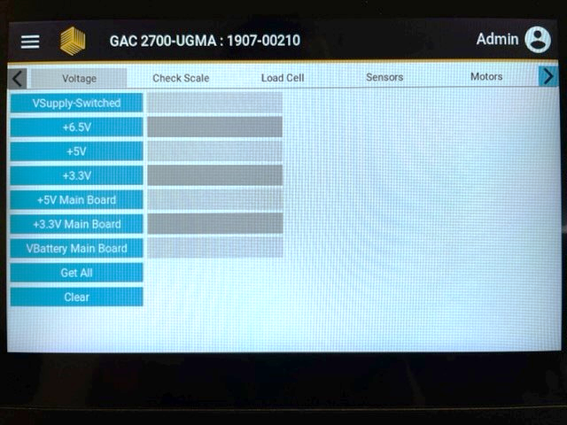

- On the diagnostic screen press the Load Cell tab.
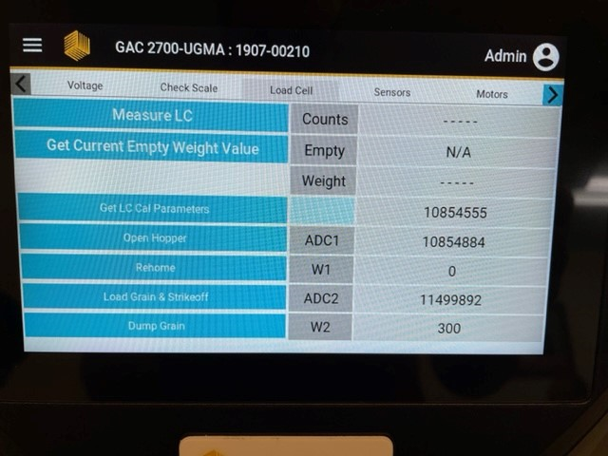

- From the Load Cell tab select “Get Current Empty Weight Value”

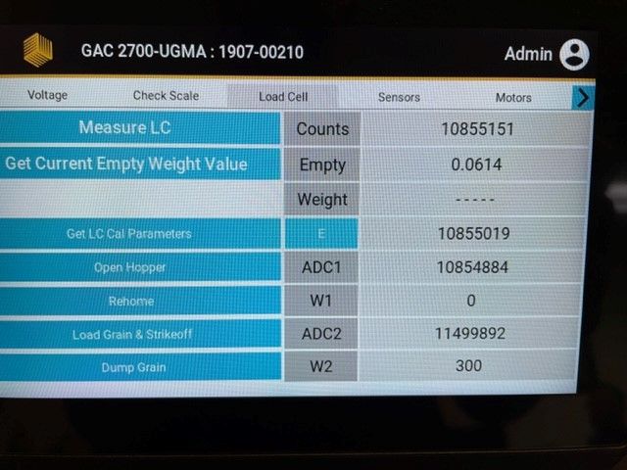

- Note the Empty cell weight
- Press the “E” button to zero out the empty cell weight.
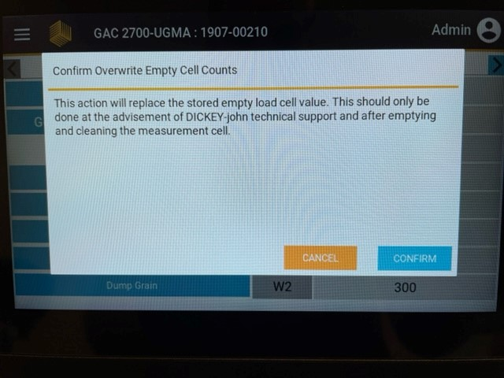

- Confirm the “Overwrite Empty Cell Counts” message
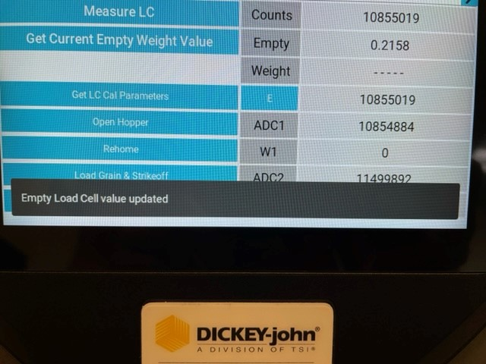
- Once the message is confirmed a message on the bottom of the screen will appear telling you that the load cell value was changed.

- Select “Get Current Empty Cell Weight” and verify the reading is between 0.0 and 0.1.

